Creating an XML document
In this section you will learn how to create and work with XML documents in XMLSpy. You will also learn how to use the various intelligent editing features of XMLSpy.
Objective
In this section of the tutorial you will learn how to do the following:
• | Create a new XML document based on the AddressLast.xsd schema.
• | Specify the type of an element so as to make an extended content model for that element available to the element during validation.

• | Insert elements and attributes and enter content for them in Grid View and Text View using intelligent entry helpers.
• | Copy XML data from XMLSpy to Microsoft Excel; add new data in MS Excel; and copy the modified data from MS Excel back to XMLSpy. This functionality is available in the Database/Table View of Grid View.

• | Sort XML elements using the sort functionality of Database/Table View.
• | Validate the XML document.

• | Modify the schema to allow for three-digit phone extensions.
Commands used in this section
In this section of the tutorial, you will mostly use the Grid View and Text View, and in one section the Schema/WSDL View. The following commands are used:
File | New. Creates a new type of XML file.
View | Text View. Switches to Text View.
View | Enhanced Grid View. Switches to Enhanced Grid View.
XML | Table | Display as Table. Displays multiple occurrences of a single element type at a single hierarchic level as a table. This view of the element is called the Database/Table View (or simply Table View). The icon is used to switch between the Table View and regular Enhanced Grid View.
F7. Checks for well-formedness.
F8. Validates the XML document against the associated DTD or Schema.
Opens the associated DTD or XML Schema file.

Creating a new XML file
When you create a new XML file in XMLSpy, you are given the option of basing it on a schema (DTD or XML Schema) or not. In this section you will create a new file that is based on the AddressLast.xsd schema you created earlier in the tutorial.
To create the new XML file:
1. | Select the menu option File | New. The Create new document dialog opens.
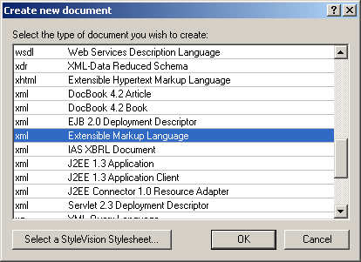
2. | Select the Extensible Markup Language entry from the dialog, and confirm with OK. A prompt appears, asking if you want to base the XML document on a DTD or Schema.
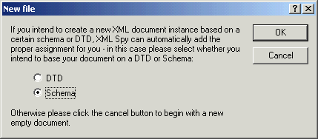
3. | Click the Schema radio button, and confirm with OK. A further dialog appears, asking you to select the schema file your XML document is to be based on.

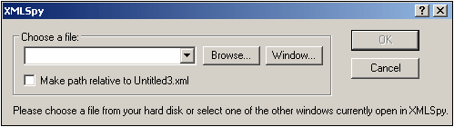
4. | Use the Browse or Window buttons to find the schema file. The Window button lists all files open in XMLSpy and projects. Select AddressLast.xsd, and confirm with OK. An XML document containing the main elements defined by the schema opens in the main window.
5. | Click the Grid tab to select Enhanced Grid View.

6. | In Grid View, the entire document is selected. Click on any element to reduce selection to that element. Your document should look something like this:

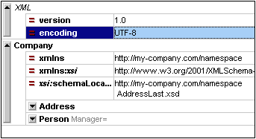
7. | Click on the icon next to Address, to view the child elements of Address. Your document should look like this:
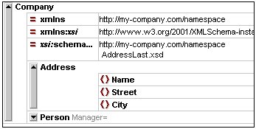

Specifying the type of an element
The child elements of Address displayed in Grid View are those defined for the global complex type AddressType (content model of which is shown in screenshot below).
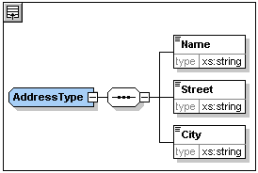
We would, however, like to use a specific US or UK address type rather than the generic address type. You will recall that, in the AddressLast.xsd schema, we created global complex types for US-Address and UK-Address by extending the AddressType complex type. The content model of US-Address is shown below.
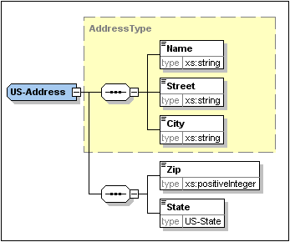
In the XML document, in order to specify that the Address element must conform to one of the extended Address types (US-Address or UK-Address) rather than the generic AddressType, we must specify the required extended complex type as an attribute of the Address element.
Do the following:
1. | Right-click the Name element, and select Insert | Attribute from the context menu.

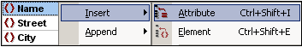
An attribute field is added to the Address element.
2. | Enter xsi:type as the name of the attribute.
3. | Press Tab to move into the next (value) field. A popup menu appears (shown below) listing the available complex types appears.
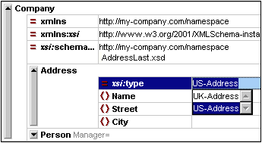
4. | Select US-Address from the list, and confirm with Enter.
Please note: The xsi prefix allows you to use special XML Schema related commands in your XML document instance. In the above case, you have specified a type for the Address element. See the XML Schema specification for more information.

Entering data in Grid View
You can now enter data into your XML document.
Do the following:
1. | Double-click in the Name value field (or use the arrow keys) and enter US dependency. Confirm with Enter.
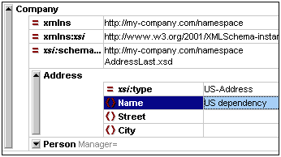
2. | Use the same method to enter a Street and City name (for example, Noble Ave and Dallas).
3. | Click the Person element and press Delete to delete the Person element. (We will add it back in the next section of the tutorial.) After you do this, the entire Address element is highlighted.

4. | Click on any child element of the Address element to deselect all the child elements of Address except the selected element. Your XML document should look like this:
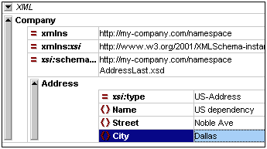

Entering data in Text View
Text View is ideal for editing the actual data and markup of XML files because of its DTD/XML Schema-related intelligent editing features.
Structural editing features
In addition, Text View provides a number of structural editing features that make editing large sections of text easy. Among these latter features are the following, which can be toggled on and off by clicking the appropriate icon.
Enables/disables line numbering.
Enables/disables the source folding margin.
Enables/disables the bookmark margin.
Inserts/removes bookmarks.
Enables/disables indentation guides.
The screenshot below shows the current XML file in Text View with all structural editing features enabled. For the sake of clarity, none of the line numbers, indentation guides, etc, will be shown in Text View in rest of this tutorial. Please see the User Manual for more information on Text View.
Comment: The example file below needs a small correction. It says "US depencency" instead of "US dependency". The screenshot was edited to be correct, but the actual file has to be changed.
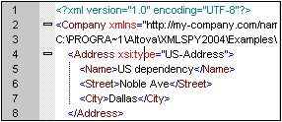
Editing in Text View
In this section, you will enter and edit data in Text View in order to become familiar with the features of Text View.
Do the following:
1. | Select the menu item View | Text view, or click on the Text tab. You now see the XML document in its text form, with syntax coloring.
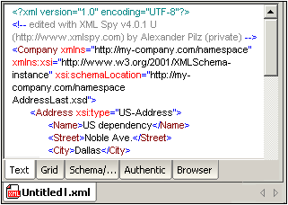
2. | Place the text cursor after the end tag of the Address element, and press Enter to add a new line.
3. | Enter the less-than angular bracket < at this position. A dropdown list of all elements allowed at that point (according to the schema) is displayed. Since only the Person element is allowed at this point, it will be the only element displayed in the list.
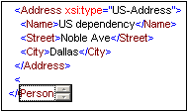
4. | Select the Person entry. The Person element, as well as its attribute Manager, are inserted, with the cursor inside the value-field of the Manager attribute.
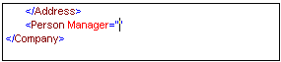
5. | From the dropdown list for the Manager attribute, select true.
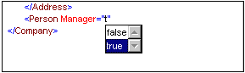
Press Enter to insert the value true at the cursor position.
6. | Move the cursor to the end of the line (using the End key if you like), and press the space bar. This opens a dropdown list, this time containing a list of attributes allowed at that point. Also, in the Attributes Entry Helper, the available attributes are listed in red. The Manager attribute is grayed out because it has already been used.
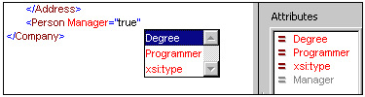
7. | Select Degree with the Down arrow key, and press Enter. This opens another list box, from which you can select one of the predefined enumerations (BA, MA, or PhD).
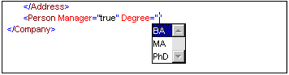
8. | Select BA with the Down arrow key and confirm with Enter. Then move the cursor to the end of the line (with the End key), and press the space bar. Manager and Degree are now grayed out in the Attributes Entry Helper.
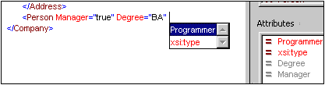
9. | Select Programmer with the Down arrow key and press Enter.
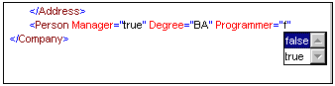
10. | Enter the letter "f" and press Enter.
11. | Move the cursor to the end of the line (with the End key), and enter the greater-than angular bracket >. XMLSpy automatically inserts all the required child elements of Person. (Note that the optional Title element is not inserted.) Each element has start and end tags but no content.
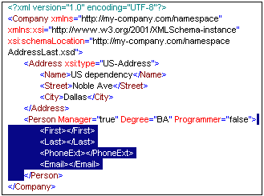
You could now enter the Person data in Text View, but let's move to Grid View to see the flexibility of moving between views when editing a document.
Switching to Grid View
To switch to Grid View, select the menu item View | Enhanced Grid View, or click the Grid tab. The newly added child elements of Person are highlighted.
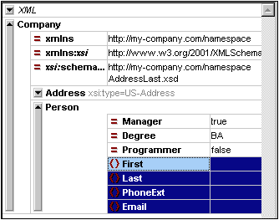
Now let us validate the document and correct any errors that the validation finds.

Validating the document
XMLSpy provides two evaluations of the XML document:
• | A well-formedness check
• | A validation check
If either of these checks fails, we will have to modify the document appropriately.
Checking well-formedness
An XML document is well-formed if starting tags match closing tags, elements are nested correctly, there are no misplaced or missing characters (such as an entity without its semi-colon delimiter), etc.
To do a well-formedness check, select the menu option XML | Check well-formedness, or press the F7 key, or click . A message appears in the Validation window at the bottom of the Main Window saying the document is well-formed.
Notice that the output of the Validation window has 9 tabs. The validation output is always displayed in the active tab. Therefore, you can check well-formedness in tab1 for one schema file and keep the result by switching to tab 2 before validating the next schema document (otherwise tab 1 is overwritten with the validation result ).
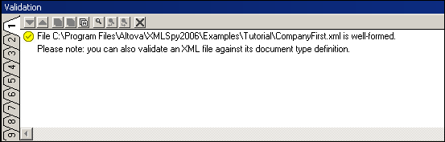
Please note: This check does not check the structure of the XML file for conformance with the schema. Schema conformance is evaluated in the validity check.
Checking validity
An XML document is valid according to a schema if it conforms to the structure and content specified in that schema.
To check the validity of your XML document, select the menu option XML | Validate, or press the F8 key, or click . An error message appears in the Validation window saying the file is not valid. Mandatory elements are expected after the City element in Address. If you check your schema, you will see that the US-Address complex type (which you have set this Address element to be with its xsi:type attribute) has a content model in which the City element must be followed by a Zip element and a State element.
Fixing the invalid document
The point at which the document becomes invalid is highlighted, in this case the City element.
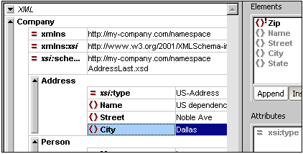
Now look at the Elements Entry Helper (at top right). Notice that the Zip element is prefixed with an exclamation mark, which indicates that the element is mandatory in the current context.
To fix the validation error:
1. | In the Elements Entry Helper, double-click the Zip element. This inserts the Zip element after the City element (we were in the Append tab of the Elements Entry Helper).
2. | Press the Tab key, and enter the Zip Code of the State (04812), and confirm with Enter. The Elements Entry Helper now shows that the State element is mandatory (it is prefixed with an exclamation mark). See screenshot below.
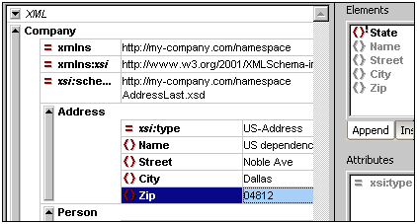
3. | In the Elements Entry Helper, double-click the State element. Then press Tab and enter the name of the state (Texas). Confirm with Enter. The Elements Entry Helper now contains only grayed-out elements. This shows that there are no more required child elements of Address.
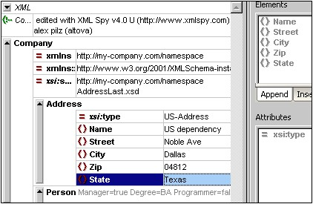
Completing the document and revalidating
Let us now complete the document (enter data for the Person element) before revalidating.
Do the following:
1. | Click the value field of the element First, and enter a first name (say Fred). Then press Enter.
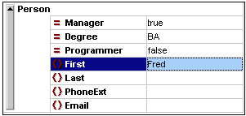
2. | In the same way enter data for all the child elements of Person, that is, for Last, PhoneExt, and Email. Note that the value of PhoneExt must be an integer with a maximum value of 99 (since this is the range of allowed PhoneExt values you defined in your schema). Your XML document should then look something like this:
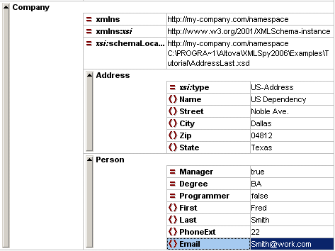
. | Click again to check if the document is valid. A message appears in the Validation window stating that the file is valid. The XML document is now valid against its schema.
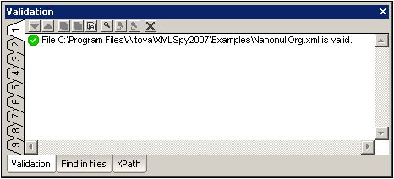
4. | Select the menu option File | Save and give your XML document a suitable name (for example CompanyFirst.xml). Note that the finished tutorial file CompanyFirst.xml is in the Tutorial folder, so you may need to rename it.
Please note: An XML document does not have to be valid in order to save it. Saving an invalid document causes a prompt to appear warning you that you are about to save an invalid document. You can select Save anyway, if you wish to save the document in its current invalid state.

Appending elements and attributes in Grid View
At this point, there is only one Person element in the document.
To add a new Person element:
1. | Click the gray sidebar to the left of the Address element to collapse the Address element. This clears up some space in the view.
2. | Select the entire Person element by clicking on or below the Person element text in Grid View. Notice that the Person element is now available in the Append tab of the Elements Entry Helper.
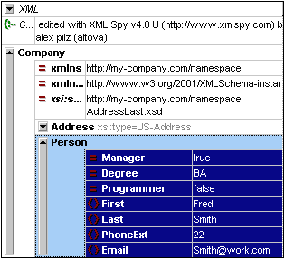
3. | Double-click the Person element in the Elements Entry Helper. A new Person element with all mandatory child elements is appended (screenshot below). Notice that the optional Title child element of Person is not inserted.
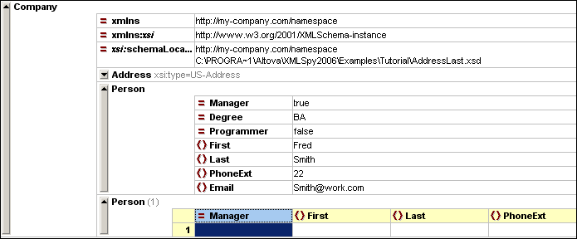
4. | Press F12 to switch the new Person element to Grid View.
5. | Click on the Manager attribute of the new Person element. Take a look at the Attributes Entry Helper. The Manager entry is grayed out because it has already been entered. Also look at the Info Window, which now displays information about the Manager attribute.

6. | In the Append tab of the Attributes Entry Helper, double-click the Programmer entry. This inserts an empty Programmer attribute after the Manager attribute.
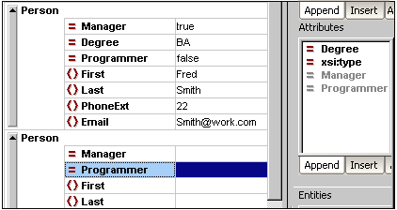
The Programmer attribute is now grayed out in the Attributes Entry Helper.

You could enter content for the Person element in this view, but let's switch to the Database/Table View of Grid View since it is more suited to editing a structure with multiple occurrences, such as Person.

Editing in Database/Table View
Grid View contains a special view called Database/Table View (hereafter called Table View), which is convenient for editing elements with multiple occurrences. Individual element types can be displayed as a table. When an element type is displayed as a table, its children (attributes and elements) are displayed as columns, and the occurrences themselves are displayed as rows.
To display an element type as a table, you select any one of the element type occurrences and click the Display as Table icon in the toolbar (XML | Table | Display as table). This causes that element type to be displayed as a table. Descendant element types that have multiple occurrences are also displayed as tables. Table View is available in Enhanced Grid View, and can be used to edit any type of XML file (XML, XSD, XSL, etc.).
Advantages of Table View
Table View provides the following advantages:
• | You can drag-and-drop column headers to reposition the columns relative to each other. This means that, in the actual XML document, the relative position of child elements or attributes is modified for all the element occurrences that correspond to the rows of the table.
• | Tables can be sorted (in ascending or descending order) according to the contents of any column using XML | Table | Ascending Sort or Descending Sort.

• | Additional rows (i.e., element occurrences) can be appended or inserted using XML | Table | Insert Row.
• | You can copy-and-paste structured data to and from third party products

• | The familiar intelligent editing feature is active in Table View also.
Displaying an element type as a Table
To display the Person element type as a table:
1. | In Grid View, select either of the Person elements by clicking on or near the Person text.
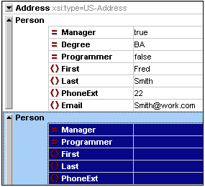
2. | Select the menu option XML | Table | Display as table, or click the Display as Table icon. Both Person elements are combined into a single table. The element and attribute names are now the column headers, and the element occurrences are the rows of the table.
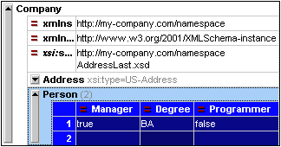
3. | Select the menu option View | Optimal widths, or click the Optimal Widths icon, to optimize the column widths of the table.
Please note: Table View can be toggled off for individual element types in the document by selecting that table (click the element name in the table) and clicking the Display As Table icon. Note however that child elements which were displayed as tables will continue to be displayed as tables.
Entering content in Table View
To enter content for the second Person element, double-click in each of the table cells in the second row, and enter some data. Note, however, that PhoneExt must be an integer up to 99 in order for the file to be valid. The intelligent editing features are active also within cells of a table, so you can select options from dropdown lists where options are available (Boolean content and the enumerations for the Degree attribute).
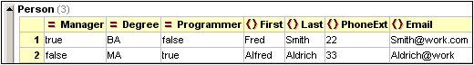
Please note: The Entry Helpers are active also for the elements and attributes displayed as a table. Double-clicking the Person entry in the Elements Entry Helper, for example, would add a new row to the table (i.e., a new occurrence of the Person element).
Copying XML data to and from third party products
You can copy spreadsheet-type data between third party products and XML documents in XMLSpy. This data can be used as XML data in XMLSpy and as data in the native format of the application copied to/from. In this section you will learn how to copy data to and from an Excel data sheet.
Do the following:
1. | Click on the row label 1, hold down the Ctrl key, and click on row label 2. This selects both rows of the table.
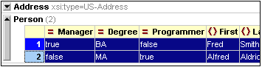
2. | Select the menu option Edit | Copy as Structured text. This command copies elements to the clipboard as they appear on screen.
3. | Switch to Excel and paste (Ctrl+V) the XML data in an Excel worksheet.
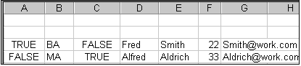
4. | Enter a new row of data in Excel. Make sure that you enter a three digit number for the PhoneExt element (say, 444).
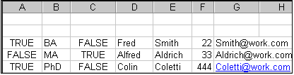
5. | Mark the table data in Excel, and select Edit | Copy to copy the data to the clipboard.
6. | Switch back to XMLSpy.

7. | Click in the top left data cell of the table in XMLSpy, and select Edit | Paste.
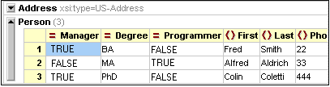
8. | The updated table data is now visible in the table.
9. | Change the uppercase boolean values TRUE and FALSE to lowercase true and false, respectively, using the menu option Edit | Replace (Ctrl+H).
Sorting the table by the contents of a column
A table in Table View can be sorted in ascending or descending order by any of its columns. In this case, we want to sort the Person table by last names.
To sort a table by the contents of a column:
1. | Select the Last column by clicking in its header.
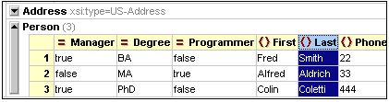
2. | Select the menu option XML | Table | Ascending sort or click on the Ascending Sort icon . The column, and the whole table with it, are now sorted alphabetically. The column remains highlighted.

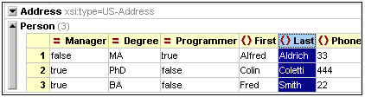
The table is sorted not just in the display but also in the underlying XML document. That is, the order of the Person elements is changed so that they are now ordered alphabetically on the content of Last. (Click the Text tab if you wish to see the changes in Text View.)
3. | Select the menu option XML | Validate or press F8. An error message appears indicating that the value '444' is not allowed for a PhoneExt element (see screenshot). The invalid PhoneExt element is highlighted .
Expand "Details" to see that PhoneExt is not valid because it is not less than or equal to the maximum value of 99.
Please Note: You can click on the links in the error message to jump to the spot in the XML file where the error was found.

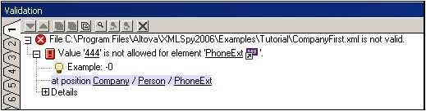
Since the value range we set for phone extension numbers does not cover this extension number, we have to modify the XML Schema so that this number is valid. You will do this in the next section.

Modifying the schema

Since two-digit phone extension numbers do not cover all likely numbers, let's extend the range of valid values to cover three-digit numbers. We therefore need to modify the XML Schema. You can open and modify the XML Schema without having to close your XML document.
Do the following:
1. | Select the menu option DTD/Schema | Go to definition or click the Go To Definition icon . The associated schema, in this case AddressLast.xsd. Switch to Schema/WSDL View (screenshot below).
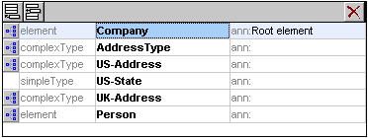
2. | Click the Display Diagram icon of the global Person element, and then click the PhoneExt element. The facet data in the Facets tab is displayed.
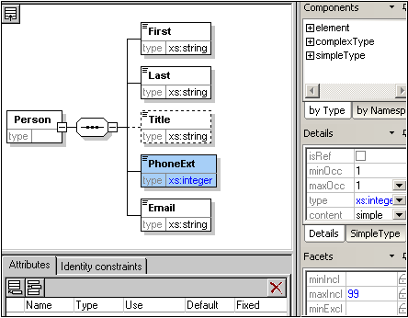
3. | In the Facets tab, double-click the maxIncl value field, change the value 99 to 999, and confirm with Enter.
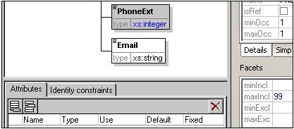
4. | Save the schema document.
5. | Press Ctrl+Tab to switch back to the XML document.
6. | Click to revalidate the XML document.
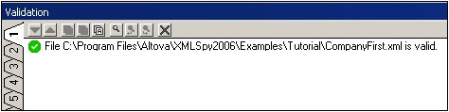
A message that the file is valid appears in the Validation window. The XML document now conforms to the modified schema.
7. | Select the menu option File | Save As... and save the file as CompanyLast.xml. (Remember to rename the original CompanyLast.xml file that is delivered with XMLSpy to something else, like CompanyLast_orig.xml).
Please note: The CompanyLast.xml file delivered with XMLSpy is in the in the Tutorial folder.

Using XSLT to transform XML
Objective
To generate an HTML file from the XML file using an XSL stylesheet to transform the XML file. You should note that a "transformation" does not change the XML file into anything else; instead a new output file is generated. The word "transformation" is a convention.
Method
The method used to carry out the transformation is as follows:
• | Assign a predefined XSL file, Company.xsl, to the XML document.
• | Execute the transformation within the XMLSpy interface using one of the two built-in Altova XSLT engines. (See note below.)
Commands used in this section
The following XMLSpy commands are used in this section:
XSL/XQuery | Assign XSL, which assigns an XSL file to the active XML document.
XSL/XQuery | Go to XSL, opens the XSL file referenced by the active XML document.
XSL/XQuery | XSL Transformation (F10), or the toolbar icon , transforms the active XML document using the XSL stylesheet assigned to the XML file. If an XSL file has not been assigned then you will be prompted for one when you select this command.
Please note: XMLSpy has two built-in XSLT engines, the Altova XSLT 1.0 Engine and Altova XSLT 2.0 Engine. The Altova XSLT 1.0 Engine is used to process XSLT 1.0 stylesheets. The Altova XSLT 2.0 Engine is used to process XSLT 2.0 stylesheets. The correct engine is automatically selected by XMLSpy on the basis of the version attribute in the xsl:stylesheet or xsl:transform element. In this tutorial transformation, we use XSLT 1.0 stylesheets. The Altova XSLT 1.0 Engine will automatically be selected for transformations with these stylesheets when the XSL Transformation command is invoked.

Assigning an XSL file
To assign an XSL file to the CompanyLast.xml file:
1. | Click the CompanyLast.xml tab in the main window so that CompanyLast.xml becomes the active document.
2. | Select the menu command XSL/XQuery | Assign XSL.

3. | Click the Browse button, and select the Company.xsl file from the Tutorial folder. In the dialog, you can activate the option Make Path Relative to CompanyLast.xml if you wish to make the path to the XSL file (in the XML document) relative.
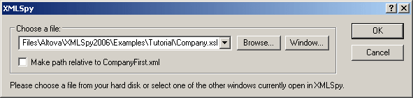
4. | Click OK to assign the XSL file to the XML document.
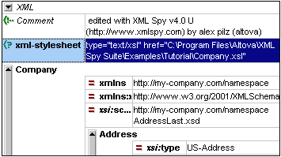

An XML-stylesheet processing instruction is inserted in the XML document that references the XSL file. If you activated the Make Path Relative to CompanyLast.xml check box, then the path is relative; otherwise absolute (as in the screenshot above).

Transforming the XML file

To transform the XML document using the XSL file you have assigned to it:
1. | Ensure that the XML file is the active document.
2. | Select the menu option XSL/XQuery | XSL Transformation (F10) or click the icon. This starts the transformation using the XSL stylesheet referenced in the XML document. (Since the Company.xsl file is an XSLT 1.0 document, the built-in Altova XSLT 1.0 Engine is automatically selected for the transformation.) The output document is displayed in Browser View; it has the name XSL Output.html. (If the HTML output file is not generated, ensure that, in the XSL tab of the Options dialog (Tools | Options), the default file extension of the output file has been set to .html.) The HTML document shows the Company data in one block down the left, and the Person data in tabular form below.
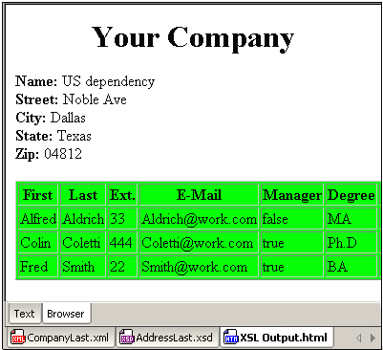
Please note: Should you only see a table header and no table data in the output file, make sure that you have defined the target namespace for your schema as detailed in Defining your own namespace at the beginning of the tutorial. The namespace must be identical in all three files (Schema, XML, and XSL).

Modifying the XSL file
You can change the output by modifying the XSL document. For example, let's change the background-color of the table in the HTML output from lime to yellow.
Do the following:
1. | Click the CompanyLast.xml tab to make it the active document, and make sure you are in Grid View.
2. | Select the menu option XSL/XQuery | Go to XSL.
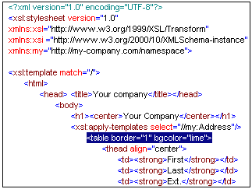
The command opens the Company.xsl file referenced in the XML document.
3. | Find the line <table border="1" bgcolor="lime">, and change the entry bgcolor="lime" to bgcolor="yellow".
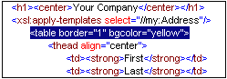
4. | Select the menu option File | Save to save the changes made to the XSL file.
5. | Click the CompanyLast.xml tab to make the XML file active, and select XSL/XQuery | XSL Transformation, or press F10. A new XSL Output.html file appears in the XMLSpy GUI in Browser View. The background color of the table is yellow.
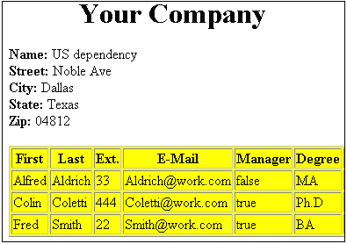
6. | Select the menu option File | Save, and save the document as Company.html.

